**ONLINE PRACTICAL CLASSES LINK (ZOOM PLATFORM)**

**STEP 1:**

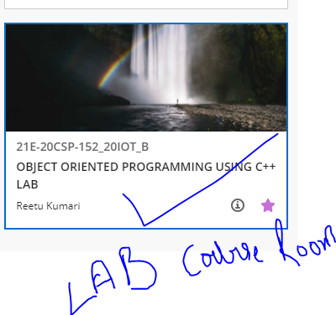

**STEP 2:**

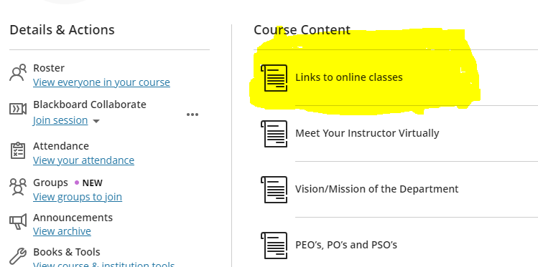

**STEP 3**

